Welcome to

Prayer in the Style of Taizé

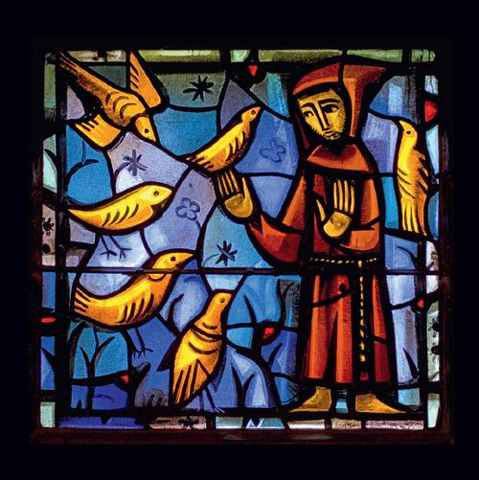

September 26, 2024

St Philip Anglican Church, Oak Bay

**Songs of Praise**

***Wait for the Lord*** **#12**

Wait for the Lord, whose day is near.

Wait for the Lord; be strong, take heart!

***Let Us Praise Your Name*** **#13**

Let us praise your name, God our Saviour, alleluia, alleluia!

Praise and bless your name, God our Saviour,

Praise and bless your name, alleluia!

**Psalm 150** *see pew Bibles p.508*

***It Is Good To Trust*** **#11**

It is good to trust in the Lord our God,

Trust and hope in the Lord our God.

——

***Kyrie 13*** (sung 3x) **#6**

Kyrie eleison, eleison. [Lord have mercy, have mercy]

**Reading:** Romans 8:5-11, vs.6b in different languages *see pew Bibles p.919*

“Paul writes: The Spirit seeks life and peace.”

***Kyrie 13*** (sung once) **#6**

Kyrie eleison, eleison. [Lord have mercy, have mercy]

——

***Stay With Us*** **#21**

Stay with us, O Lord Jesus Christ, night will soon fall.

Stay with us, O Lord Jesus, Christ, light in our darkness.

*Prayer continues with a period of silence, followed by*

***O Lord Hear My Prayer* #20**

O Lord, hear my prayer, O Lord, hear my prayer. When I call, answer me.

O Lord, hear my prayer, O Lord, hear my prayer. Come and listen to me.

——

**Intercessions/Litany of Praise**

Response between intercessions: **May your word enlighten us**.

*Let us say together the prayer Jesus taught us:*

Our Creator in heaven, hallowed be your name,

your kingdom come, your will be done, on earth as in heaven.

Give us today our daily bread.

Forgive us our sins as we forgive those who sin against us.

Save us from the time of trial, and deliver us from evil.

For the kingdom, the power, and the glory are yours, now and for ever. Amen.

**Prayers around the Cross**

***In God Alone*  #19**

In God alone my soul can find rest and peace, in God my peace and joy.

Only in God my soul can find its rest, find its rest and peace.

***Within Our Darkest Night* #37**

Within our darkest night, you kindle the fire

that never dies away, never dies away.

***Stay With Me* #8**

Stay with me, remain here with me, watch and pray, watch and pray.

**Concluding Prayer**

Light of life, when we do not see how to go forward any more, transfigure the nights of our heart by your gentle presence. Hasten the day when the shadows will disappear and you will be all in all. And we will know you as you already know us.

***Bless The Lord* #9**

Bless the Lord, my soul, and bless God’s holy name,

Bless the Lord, my soul, who leads me into life.

***This Is The Day* #17**

(O -- ) This is the day the Lord has made! (O -- ) Alleluia, alleluia!

All words and music: Jacques Berthier, Taizé Community.

© Les Presses de Taizé, GIA Publications, Inc., agent

Reproduced with permission under OneLicense no. A-722445

Taizé is a village in the Burgundy region of France, where in 1940 Brother Roger (Schütz) founded what would become the Christian monastic Taizé Community. It is not affiliated with the Roman Catholic Church or any Protestant denomination. There are about 100 brothers from different church backgrounds and ca. 30 countries, who live in community and host 100,000 visitors, mainly young people, in a typical year. The three daily prayer gatherings include singing short musical refrains that are now used in churches around the world.

The form of prayer and the music we use today originates from this ecumenical monastic community in Taizé.

Cover image*: St Francis preaching to the birds. Stained glass, produced by the Taizé Community for the parish church, Eglise Sainte-Marie-Madeleine, in the village of Taizé.*

The feast of St Francis of Assisi, patron saint of animals and the environment, on 4 October marks the end of the Season of Creation observed throughout September by many churches around the world. **#seasonofcreation**

**Next Taizé Prayer at St Philip: Thursday 24 October, 7pm.**

28 November, 31 December - New Year's Eve

27 February, 27 March

**St Philip Anglican Church, 2928 Eastdowne V8R 5R8**

[**www.taize.fr**](http://www.taize.fr)[**www.stphilipvictoria.ca**](http://www.stphilipvictoria.ca)